 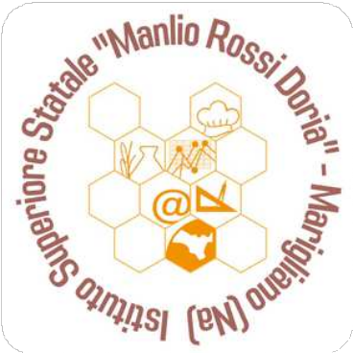

**GROUP MOBILITY**

**Escola Secundária de Castro Daire - Programme of the week 19 – 23 th may 2025**

|  |  |  |  |  |  |
| --- | --- | --- | --- | --- | --- |
| **Día** | **Monday, 19th may** | **Tuesday, 20th may** | **Wednesday, 21th may** | **Thursday, 22nd may** | **Friday, 23rd may** |
| **Morning**  *Lunch* | **9h00: Reception.**  **Meeting with the headmaster**  **Introduction of our school**  **10h15 Coffee break**  **10h30 - 12h15: Visit of the school**  **12h30: Lunch at school canteen.** | **9h00: Food presentations (dishes that not only celebrate our culinary heritage but also promote a healthier lifestyle.) Marigliano students’ presentation**  **11h25: Activity in class with Spanish class students (12th grade)**  **12h 30: Lunch at school canteen.** | **9h00: Cultural visit to Viseu (district capital)**  **Visit the Grao Vasco National Museum**  **Visit of the Cathedral and its treasure**  **Lunch at Palacio do Gelo mall (you eat wherever you want, there are a lot of options of restaurants).** | **9h00: Activity with VET Restaurant / Bar students. Make collaborative meal between Cicciano and Castro Daire students**  **(Appetizer, main dish, dessert)**  **Lunch cooked by the students at VET kitchen** | **09h00: Exchange with Portuguese students**  **10h30-11h20: Meeting with the Erasmus coordinator. Evaluation of the mobility.**  **11:30: Delivery of the certificates of participation.**  **Free Lunch** |
| **Afternoon**  **17h: end of activities** | **14h00: Reception at Paiva and Montemuro. Interpretation and Information Centre (guided our). Visit to Castro Daire Church and Regional Museum**  **Little excursion to Pombeira Viewpoints** | **14h 30: Erasmus activity with Spanish class students (11th grade)- Peddy-paper (discovering Castro Daire by an orienteering route with the app Action Bound).** | **Walking route around Viseu** | **Exchange point of view with Portuguese students** | **Visit Aveiro town** |